Menasha timeline: City celebrates 150 years as 'Your Place on the Water'
Duke Behnke
Appleton Post-Crescent. Published online on Thursday, February 29, 2024.

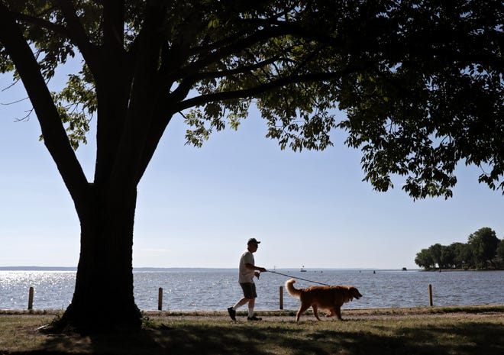

MENASHA — Proudly, Menasha brands itself as "Your Place on the Water," and the slogan fits as well today as it would have 150 years ago, when the community first incorporated as a city.
The Fox River brought French explorers and white settlers to the area, and it provided power for flour mills, paper mills and other industries. Nearby, Lake Winnebago and Little Lake Butte des Morts have long yielded abundant opportunities for boating, sailing, kayaking and fishing.
Much of Menasha's new growth — starting with the Menasha Marina and extending to Banta Lofts, The Brin on Main and the renovation of Jefferson Park — ties to the water.
Along with Neenah and Fox Crossing, Menasha is promoted as the Waterfront Area by the Fox Cities Convention & Visitors Bureau due to its easy, at-grade access to the water.
Most of Appleton, in contrast, sits high above the river.
"You could be in downtown Appleton and not know there is a river down there," Pam Seidl, the bureau's executive director, told The Post-Crescent, "whereas the easiest places to experience and get really close to both the Fox River and Lake Winnebago happen in Menasha, and in Neenah as well."
To celebrate Menasha's sesquicentennial as a city Tuesday, The Post-Crescent assembled a timeline of important events in the community's history.
The list isn't inclusive of all milestones, but it provides a synopsis of how Menasha has grown and prospered on the water.

Menasha means 'settlement on the island'
1835: White settlers arrive in what is now Menasha.

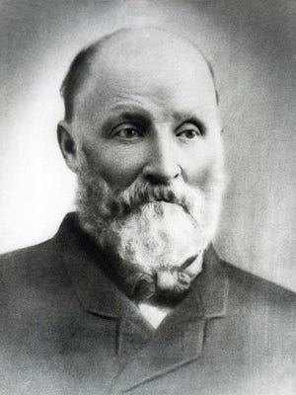

1848: Curtis Reed, known as the father of Menasha, purchases and helps plat land that would become the heart of the community. He soon starts work on the navigational canal that opens Menasha to commerce and industry.
Sarah Doty, the wife of former territorial Gov. James Duane Doty, names Menasha after the Native American word for "the island," according to the Wisconsin Historical Society. Encyclopedia Britannica says Menasha took its name from a Native American word meaning "settlement on the island."
1852: Elisha D. Smith purchases a struggling wooden pail factory. It incorporates in 1872 as Menasha Wooden Ware Co. and becomes the largest woodenware manufacturer in the world. Today it operates as Menasha Corp., a global packaging company.
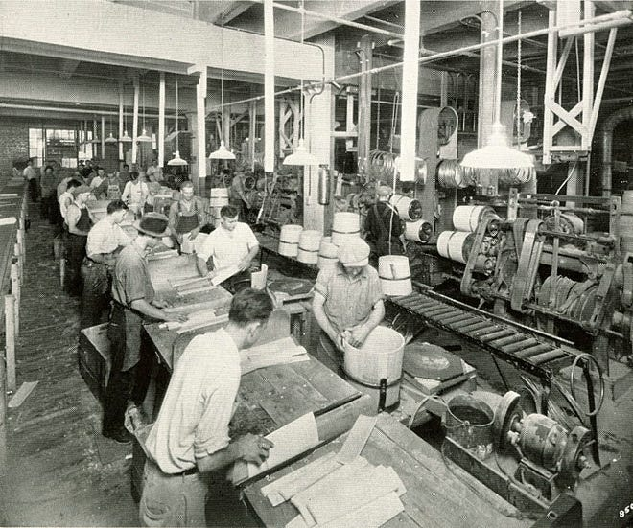
Curtis Reed serves a village president
1853: Menasha incorporates as a village. Curtis Reed is elected president.
1856: For the first time, boats can travel uninterrupted between Lake Winnebago and Green Bay.
1871: Wisconsin Central Railroad is organized by George Reed and his associates at the National Hotel. The first train runs from Menasha to Waupaca.
1874: Menasha incorporates as a city.
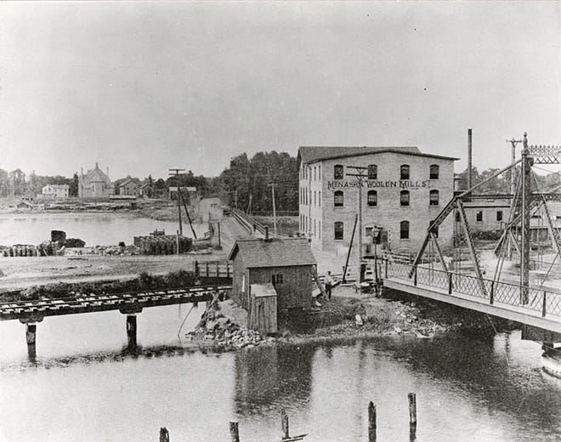

Paper mills become part of the community fabric
1881: Paper manufacturer George A. Whiting partners with William Gilbert to start the Whiting and Gilbert Co.
Later Whiting buys out Gilbert and incorporates the business as George A. Whiting Paper Co.
John Strange establishes the Strange Pail and Tub Factory. By 1891, it becomes the John Strange Paper Co. and specializes in the production of kraft paper.
1887: William Gilbert and his four sons start the Gilbert Paper Co.
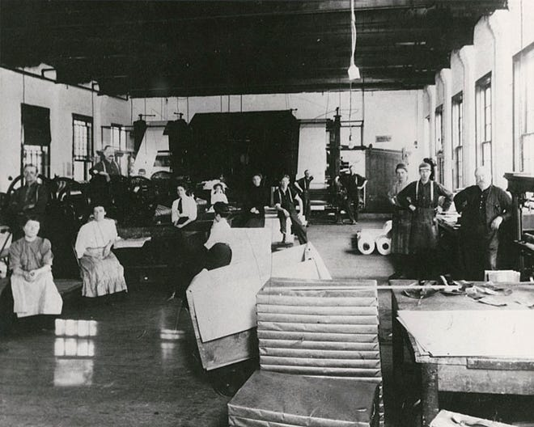
Elisha D. Smith donates 23 acres of wooded land to the city for Smith Park, which includes indigenous effigy mounds that are evident today.

Walter brothers purchase Island City Brewery
1888: Christian, Martin and Matthaus Walter purchase the bankrupt Island City Brewery at the corner of Nicolet Boulevard and Ahnaip Street and establish Walter Bros. Brewing Co.
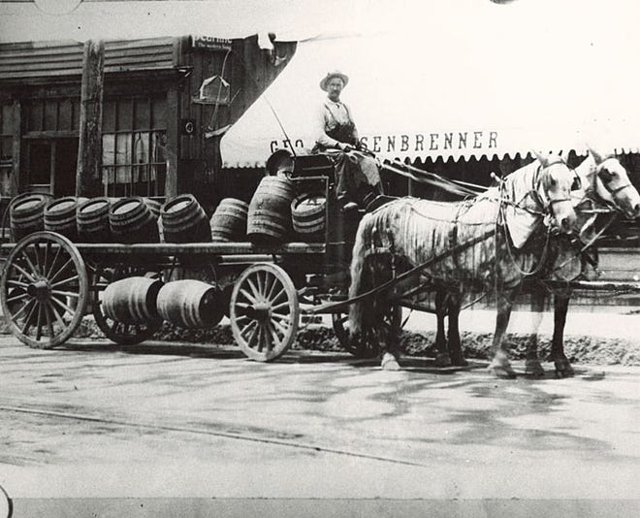
Sixteen people die after a fire and explosion at the Whiting paper mill. The tragedy became known as "Menasha's Woe" in the Menasha Saturday Evening Press.
1898: The Elisha D. Smith Library opens with an endowment from its namesake.
​1900: The population of Menasha is 5,589, according to the U.S. Census.

George Banta founds printing and publishing giant
1901: George Banta Printing Co. is founded. It is renamed George Banta Publishing Co. and becomes one of the nation's largest printing and digital imaging companies.
1906: Hotel Menasha, designed by William Waters, opens. It serves as a hub of the city.
1912: Menasha installs a diesel generator to supply electric light and power.
1915: Peerless Paper Products Co., the forerunner to Wisconsin Tissue Mills, is founded. The business changes hands through the years and now is known as Essity.
1928: The Brin Building opens. It includes a bowling alley, theater and apartments.
1936: Fire destroys Menasha High School. A new high school opens two years later.
1942: Menasha's Elmer Burr dies after throwing himself on a hand grenade, smothering the explosion with his body and saving the life of his company commander while serving in Buna, New Guinea, during World War II. Burr is awarded the Medal of Honor for his actions.
1946: Banta constructs its 42,000-square-foot Midway Plant.

Koslo pitches for Giants in World Series opener
1951: Menasha's Dave Koslo pitches for the New York Giants in the World Series opener. He gets the win against the New York Yankees.
1958: A swimming pool is built at Jefferson Park. It would be renovated in 1990.
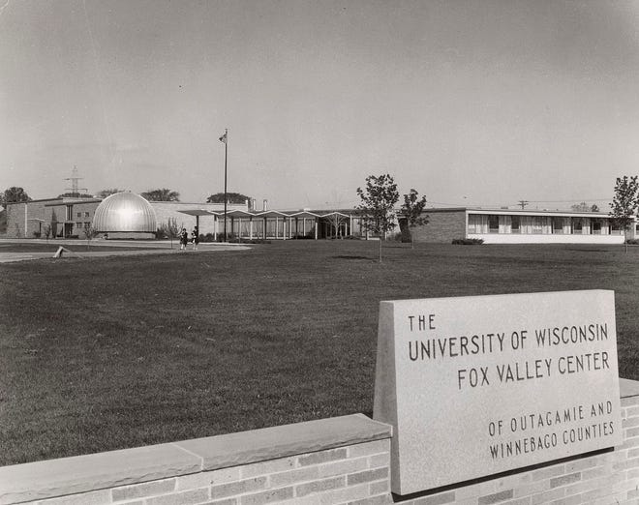
1960: The University of Wisconsin-Fox Valley Center opens on Midway Road.
1964: A four-story box plant owned by Menasha Corp. burns down. The company subsequently builds a new facility along Interstate 41 in Neenah.
Calder Field is built with the help of the Banta Co. Foundation
1968: Menasha's Kenneth Stumpf is awarded the Medal of Honor by President Lyndon Johnson for his heroic actions in the Vietnam War.
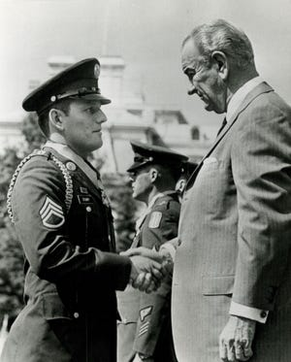
1969: A new 28,000-square-foot Elisha D. Smith Public Library built at $592,000.

Menasha overwhelmingly rejects consolidation with Neenah
1973: Menasha voters reject consolidation with Neenah by a vote of 3,179 to 884.
1987: Menasha builds an 87-slip marina along the Fox River canal.
1989: The Tayco Street drawbridge collapses, narrowly missing the Spirit of the Fox excursion boat that was carrying 46 passengers.
1993: James and Monica Taylor organize FirstEve, Menasha's annual New Year's Eve celebration, at Curtis Reed Square. It runs for 30 years.
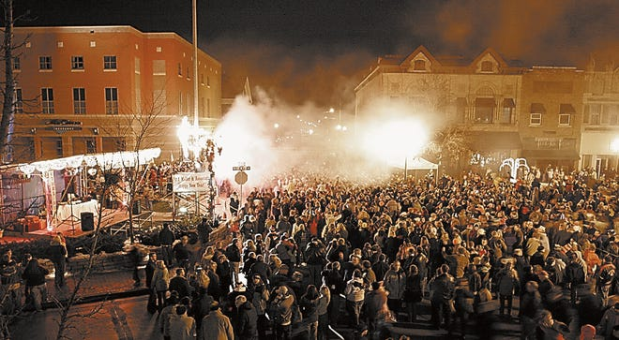
2000: The population of Menasha is 16,331, according to the U.S. Census.

Menasha steam plant endeavor ends in default
2004: Menasha approves converting its coal-fired power plant into a coal-fired steam plant to serve nearby industries. The project ends up costing $41 million, more than three times the original estimate of $12.8 million.
The government-ordered cleanup of PCBs from Little Lake Butte des Morts begins. The six-year project removes and landfills 372,000 cubic yards of sediment and caps 114 acres of low-level PCB deposits.
2009: The debt-ridden steam plant closes. The move comes after the city goes into default after paying only $2 million of the $24 million it owes to bondholders.
2014: The Menasha Bluejays defeat Waukesha West 35-17 to win the WIAA Division 2 state football championship at Camp Randall Stadium in Madison.
2015: A random shooting spree on the Fox Cities Trestle Trail kills four people and critically injures another.
The Menasha lock is closed by order of the Wisconsin Department of Natural Resources to prevent the round goby, an invasive species, from swimming upstream to Lake Winnebago's prized fishery.

Downtown investors build eight-story office building
2016: A group of investors, operating as Menasha Downtown Development Corp., opens a $12.6 million office building, known as One Menasha Center, on Main Street. Faith Technologies occupies the upper seven floors.

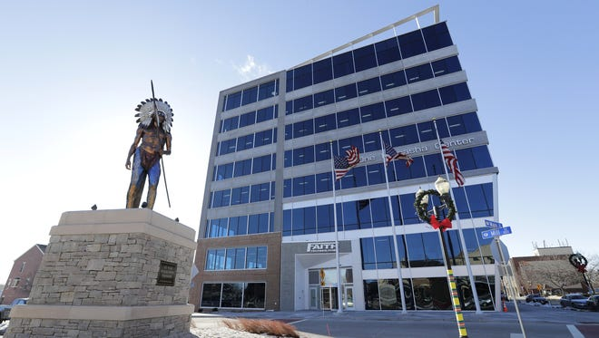
2018: Menasha, Neenah and Fox Crossing celebrate the opening of the Loop the Lake recreational trail.
Fire destroys the Brin Building, including its historic theater.
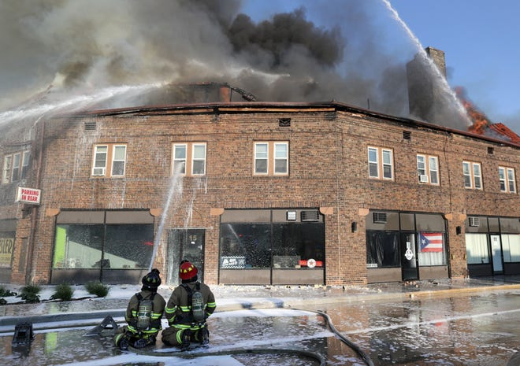
2020: The population of Menasha is 18,268, according to the U.S. Census.
2021: Fire destroys the former Whiting Paper Mill at 100 River St.
2023: A new $33 million Racine Street bridge opens to traffic.
2024: Menasha celebrates its sesquicentennial.
Sources: The Post-Crescent; "In This Century: A History of Winnebago County in the 20th Century" by Dave Engel and Michael Goc; "Centennial memories: A Brief History of Menasha, Wisconsin" by James Auer; "History of Winnebago County" by Richard Harney; Wisconsin Historical Society; Menasha's Sesquicentennial website.

